SCHOOL OF COMPUTER SCIENCE
RENAISSANCE UNIVERSITY
INDORE (M.P.)
CERTIFICATE

This is to certify that the dissertation entitled “CAMPUS-XECPTIONS” submitted by “SHUBHAM JHADE, RAVI RAJ RAJAK, SHUDHANSHU SHUKLA” is approved for the fifth semester Project of Bachelor of Computer Application..

Internal Examiner External Examiner
Date: 03/02/2026 Date:

Head (SOCS, RU)
Date: 03/02/2026

SCHOOL OF COMPUTER SCIENCE
RENAISSANCE UNIVERSITY
INDORE (M.P.)
DECLARATION
I hereby declare that the project titled “CAMPUS-XECPTIONS” prepared and submitted by me for Project of Bachelor of Computer Application to School of Computer Science, Renaissance University, Indore in 5th semester is my original work and it is done by me to the best of my knowledge. There is no material copied from other resources.

Name: RAVI, SHUBHAM, SHUDHANSHU
Date: 03/02/2026

ACKNOWLEDGMENT
I would like to express my special thanks of gratitude to my teacher Mr. Wakil Gohri as well as our Academic Coordinator Ms. Riya Upadhyay who gave me the golden opportunity to do this wonderful project on the topic “CAMPUS XECPTIONS”, which also helped me in doing a lot of research and I came to know about so many new things I am really thankful to them.
Secondly, I would also like to thank my parents and friends who helped me a lot in finalizing this project within the limited time frame.

Student Names : SHUBHAM, RAVI, SHUDHANSHU

MINOR PROJECT REPORT
CAMPUS-XECPTIONS

1: Introduction
1.1 Overview of the Project
"CampusXceptions" (also referred to as Innovation Lab) is a web-based social networking application designed specifically for campus environments. It facilitates collaboration, idea sharing, and social interaction among students and administrators. The application is built using the MERN stack (MongoDB, Express.js, React.js, Node.js), providing a robust, full-stack solution with a modern, dark-themed user interface.

1.2 Problem Definition
Current social media platforms are often too generic, distracting, or lack the specific administrative oversight required for a focused academic or campus environment. Students need a dedicated space to share innovative ideas and project updates without the noise of global social networks. Additionally, there is a need for a platform where user access can be strictly moderated by administrators to ensure a safe community.

1.3 Objectives of the Project
To develop a full-stack web application that allows users to register, login, and create posts.
To implement a secure authentication system with Admin approval functionality.
To create an interactive feed where users can view, like, and comment on posts.
To provide an Admin Dashboard for managing user access (approval/rejection) and content.
To implement a responsive, user-friendly interface using React.js.

1.4 Scope of the Project
The scope includes a web application accessible via modern web browsers. It covers two primary user roles:
Student/User: Can register, view feed, create posts (text + images), like, and comment.
Administrator: Can approve pending registrations, view all users, and delete inappropriate users or content.
The current scope uses local storage for images and session-based authentication.

1.5 Applications of the Project
College/University internal social networks.
Innovation Labs and Tech Clubs for sharing project updates.
Alumni networks for specific institutions.
Departmental communication portals.

2: Literature Review
2.1 Existing System
Existing systems include global social media giants like Facebook, LinkedIn, or Twitter, as well as legacy college portals that are often outdated, static, and lack social interactivity.

2.2 Limitations of Existing System
Noise & Distraction: Global platforms contain advertisements and irrelevant content.
Lack of Control: Institutions cannot easily moderate who joins or what is posted on public platforms.
Poor UI/UX: Traditional college portals often suffer from outdated interfaces and poor mobile responsiveness.

2.3 Proposed System
The proposed "CampusXceptions" system is a tailored solution that combines the interactivity of modern social media with the control of an institutional portal. It features a "Cyberpunk/Dark Mode" UI to appeal to tech-savvy students and uses a Single Page Application (SPA) architecture for a seamless experience.

2.4 Advantages of the Proposed System
Focused Environment: Content is strictly relevant to the campus/lab.
Admin Moderation: Registration requires admin approval, preventing unauthorized access.
Modern Tech Stack: Built on MERN, ensuring scalability and performance.
Customizable: The codebase can be easily extended to add features like real-time chat or AI integration.

3: System Analysis
3.1 Requirement Analysis
The system requires a client-side interface for user interaction and a server-side API for data processing. It must handle image uploads, maintain user sessions securely, and store data persistently.

3.2 Functional Requirements
User Module: Registration (with 10-digit mobile validation), Login, Profile Management.
Post Module: Create Post (Text & Image), Delete Post (Author only), View Feed.
Interaction Module: Like Post, Comment on Post.
Admin Module: View Pending Users, Approve/Reject Users, Delete Users.

3.3 Non-Functional Requirements
Performance: The application should load quickly using React's virtual DOM.
Security: Passwords must be handled securely; sessions should be managed via HTTP-only cookies.
Reliability: The system should handle file uploads without crashing (using Multer).
Usability: The interface should be intuitive with clear feedback (e.g., error messages for invalid inputs).

3.4 Feasibility Study
Technical: The MERN stack is open-source and well-documented.
Economic: Development costs are low as it uses free, open-source technologies.
Operational: The system is easy to deploy and maintain on standard servers or localhost.

4: System Design
4.1 System Architecture
The project follows a Client-Server Architecture.
Frontend (Client): React.js (Vite) interacts with the user.
Backend (Server): Node.js/Express.js handles API requests.
Database: MongoDB stores User and Post data.

4.2 Module Description
Authentication: Handles login/register logic and session management.
File Handler: Uses 'Multer' middleware to process and store uploaded images.
Database Controller: Mongoose models define the schema for Users and Posts.

4.3 Data Flow Diagram (DFD)
(You can describe the flow):
User Input -> React Form -> Axios/Fetch Request -> Express Route -> Mongoose Controller -> MongoDB -> Response sent back to Client.

4.4 Use Case Diagram
Actors: User, Admin.
Use Cases: Login, Register, Post Idea, Like, Comment, Approve User, Delete User.

4.5 ER Diagram
Entity User: (Attributes: ID, Username, Password, Mobile, IsAdmin, IsApproved)
Entity Post: (Attributes: ID, Content, ImageUrl, UserID (Foreign Key), Likes Array, Comments Array)
Relationship: One User can create Many Posts (1:N).

4.6 Database Design
The database is NoSQL (MongoDB).
Collection users: Stores user credentials and status.
Collection posts: Stores post content, image paths, and nested arrays for comments/likes.

5: Technology Used
5.1 Programming Language
JavaScript (ES6+) for both client and server-side logic.

5.2 Frontend Technology
Library: React.js (v18+)
Build Tool: Vite
Styling: CSS3 (Custom Dark Theme)
Routing: React Router DOM

5.3 Backend Technology
Runtime: Node.js
Framework: Express.js
Middleware: CORS, Multer, Express-Session

5.4 Database
MongoDB (NoSQL Database)

5.5 Tools / IDE Used
Visual Studio Code (VS Code)
Git / GitHub for version control
Google Chrome (for testing/debugging)

5.6 Hardware & Software Requirements
Hardware: i3 Processor or higher, 4GB RAM minimum.
Software: Windows/Mac/Linux OS, Node.js installed, MongoDB installed.

6: Implementation
6.1 Description of Modules
Login Module: Verifies username/password and checks isApproved flag.
Feed Module: Fetches posts from the API and renders them as cards.
Registration Module: Validates inputs (e.g., Mobile length == 10) before sending data.

6.2 Algorithm / Logic Used
Session Management: Uses cookies to track logged-in users across requests without sending credentials every time.
CORS Policy: Whitelists localhost:5173 to allow secure cross-origin resource sharing.

6.3 Code Snippets
(You can paste small parts of your code here, for example, the Register Route):
// Register Route with Validation
app.post('/api/auth/register', async (req, res) => {
const { username, password, mobile } = req.body;
if (mobile.length !== 10) return res.status(400).json({ error: "Mobile must be 10 digits" });
await User.create({ username, password, mobile, isApproved: false });
res.json({ success: true });
});

Test Case ID Test Scenario Expected Result Actual Result Status
TC_01 User registers with 9-digit mobile Error: "Must be 10 digits" Error displayed Pass
TC_02 Unapproved user tries to login Error: "Account pending approval" Error displayed Pass
TC_03 Admin clicks "Approve" User status updates to Active User approved Pass
TC_04 User uploads image post Post8: Results and Discussion

6.4 Screenshots of the System

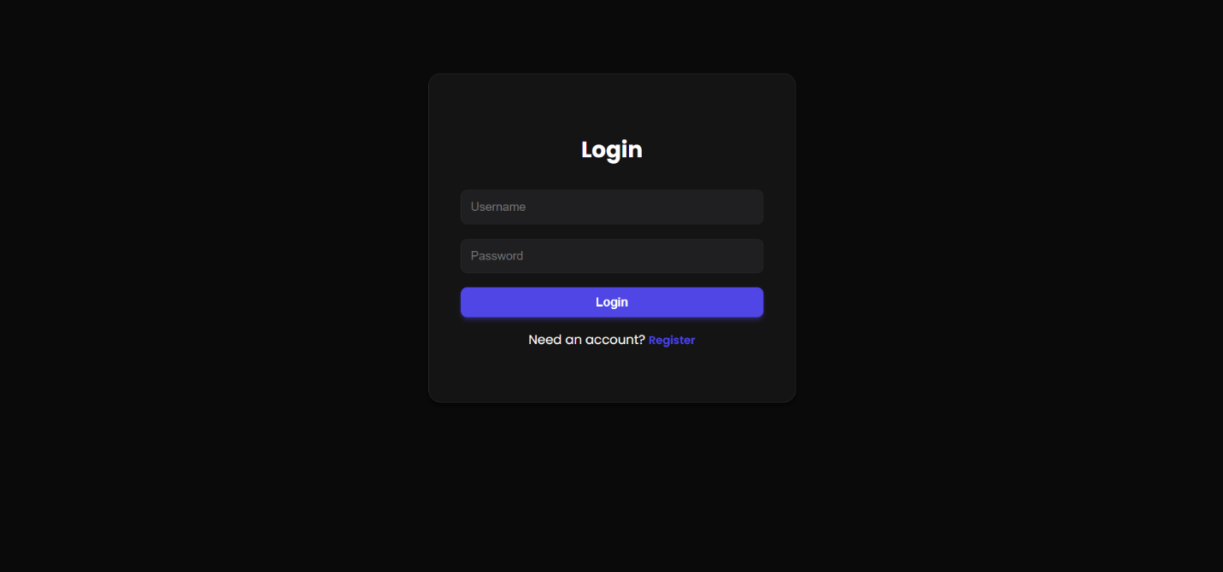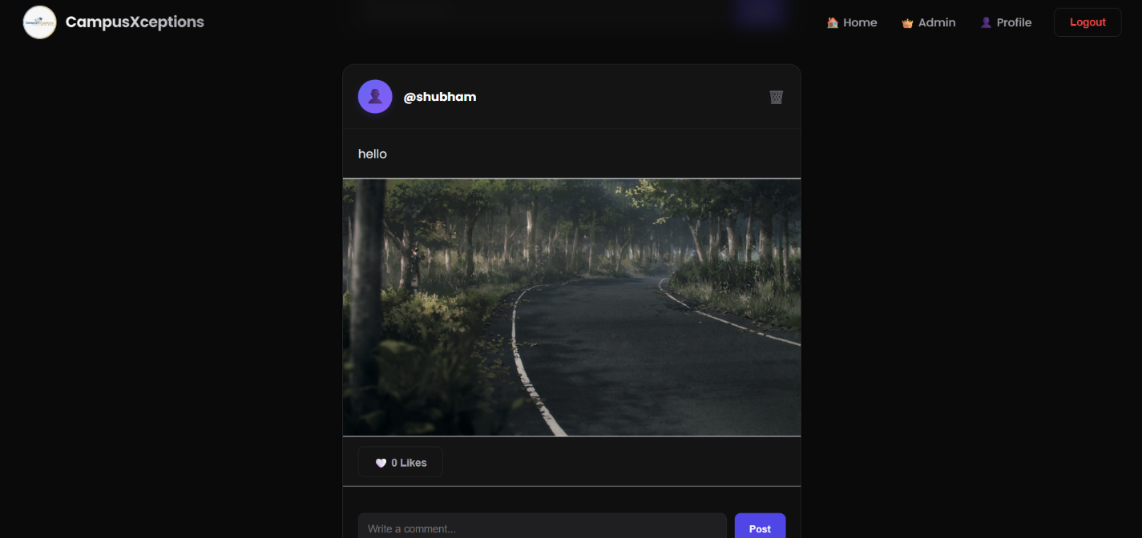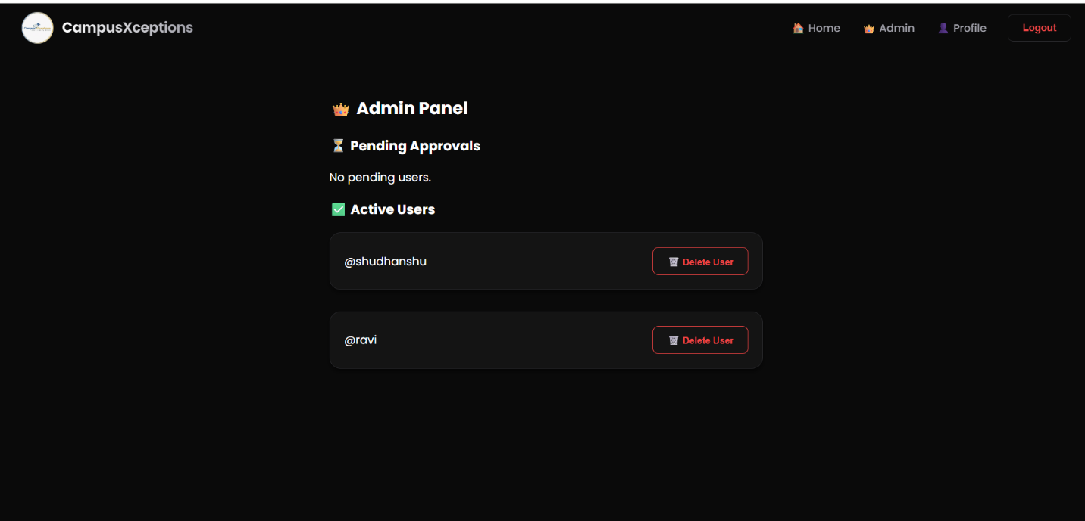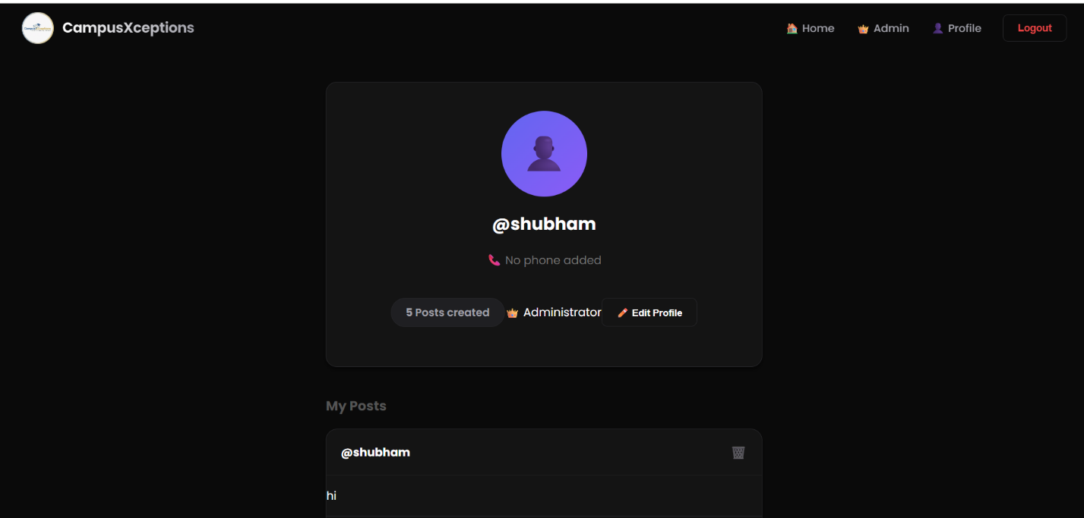

7: Testing
7.1 Testing Strategy We used Unit Testing for individual components (like the Navbar) and Integration Testing to ensure the Frontend communicates correctly with the Backend API.
7.2 Types of Testing
- Black Box Testing: Testing functionality without looking at the internal code structure.
- Validation Testing: Ensuring inputs (like mobile numbers) are validated correctly.
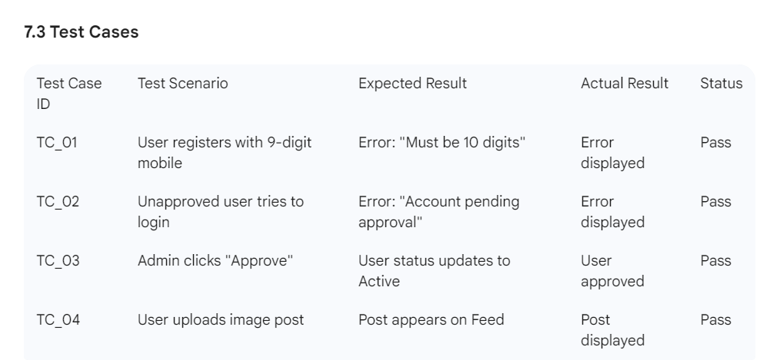

8: Results and Discussion
8.1 Output Screens
The project successfully renders a responsive, dark-themed UI. The feed updates dynamically upon posting, and the admin panel reflects real-time data changes.
8.2 Performance Analysis
The application is lightweight. React's component-based architecture ensures that only necessary parts of the DOM are updated, resulting in a smooth user experience even with multiple posts.
8.3 Comparison with Existing System
Compared to static HTML/PHP portals, CampusXceptions offers a much faster, app-like experience (SPA) with no page reloads during navigation.

9: Conclusion and Future Scope
9.1 Conclusion
The "CampusXceptions" project was successfully designed and implemented. It meets all primary objectives: secure authentication, admin moderation, and a collaborative social feed. The use of the MERN stack allowed for rapid development and a unified JavaScript codebase.
9.2 Limitations
Images are stored locally, which is not scalable for production.
Lack of real-time chat (Instant Messaging).
Password encryption (Hashing) is not yet implemented in the basic version.9:

CONSLUSION
CampusXceptions provides a collaborative digital space for students to connect, share ideas, and work together. It
encourages innovation, enhances communication skills, and supports modern collaborative learning practices.

